Program1

Half Day

2500 THB/Person

: Learn everything from seed to harvest

: Discover the industrial cultivation , greenhouse growing

: Take your pick of farm-produced

Goodies,along with a special gife set

: Enjoy the ultimate experience of “Smoke while trying out the strains you acquired from the farm using a vape or bong or other ways you prefer.

: Eat lunch.

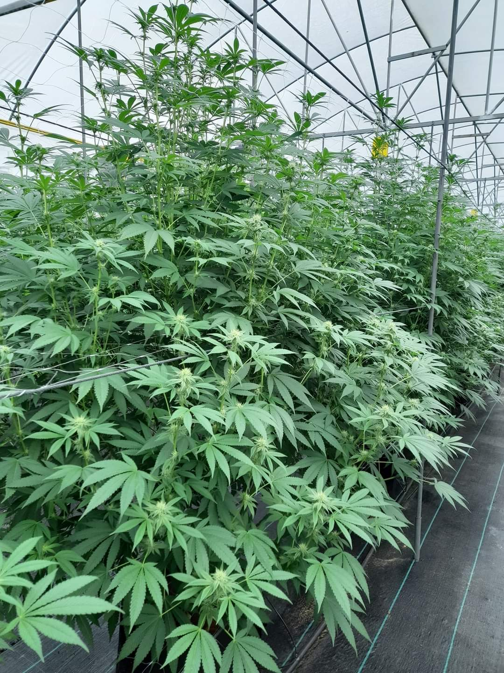 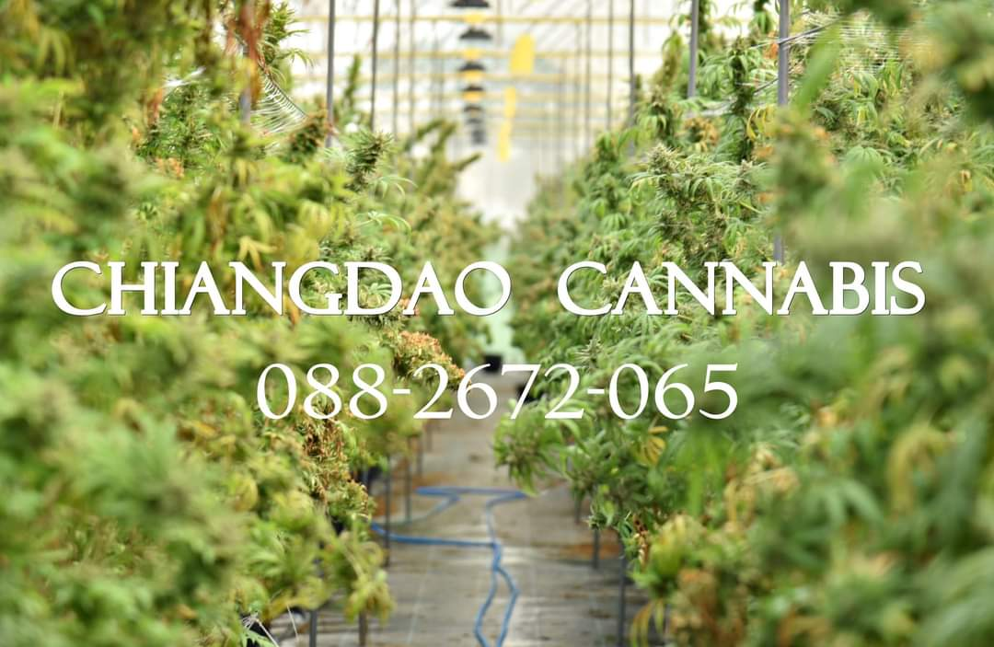

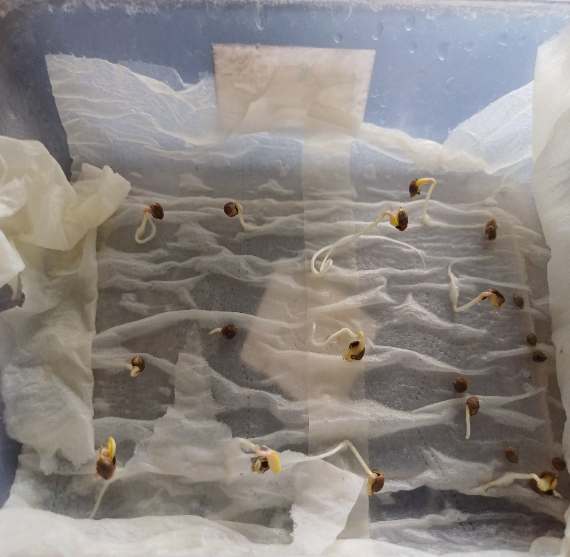 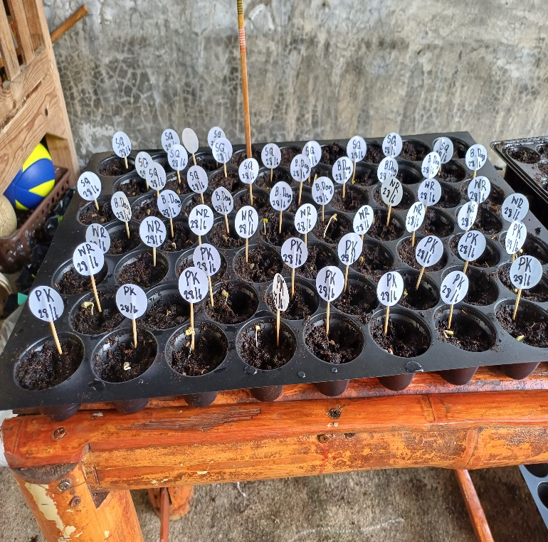

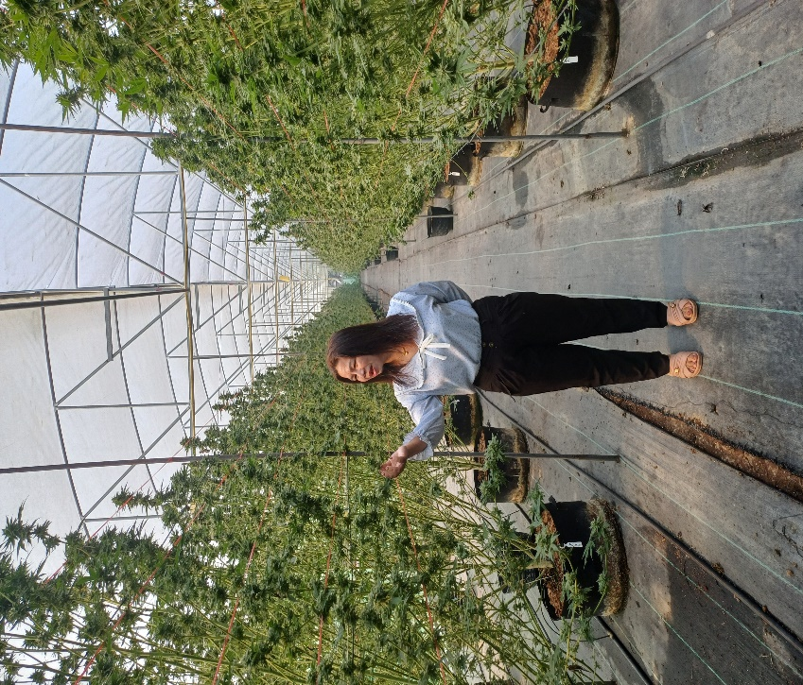 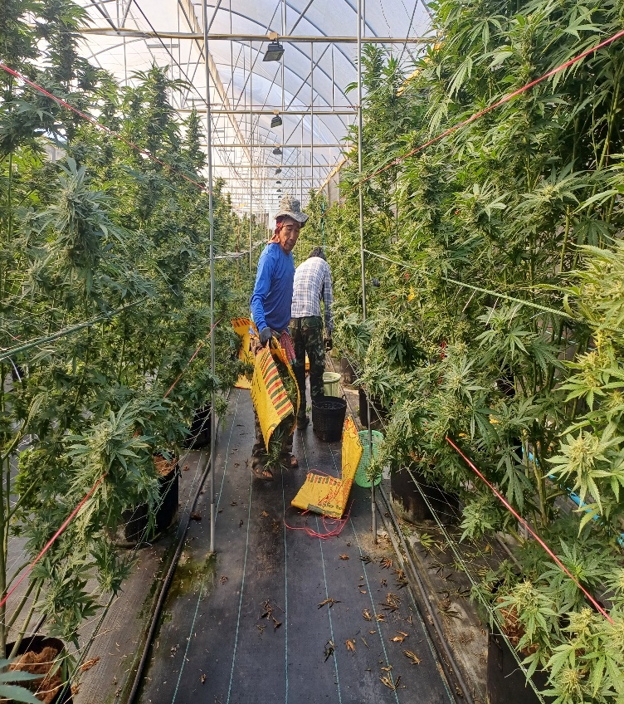

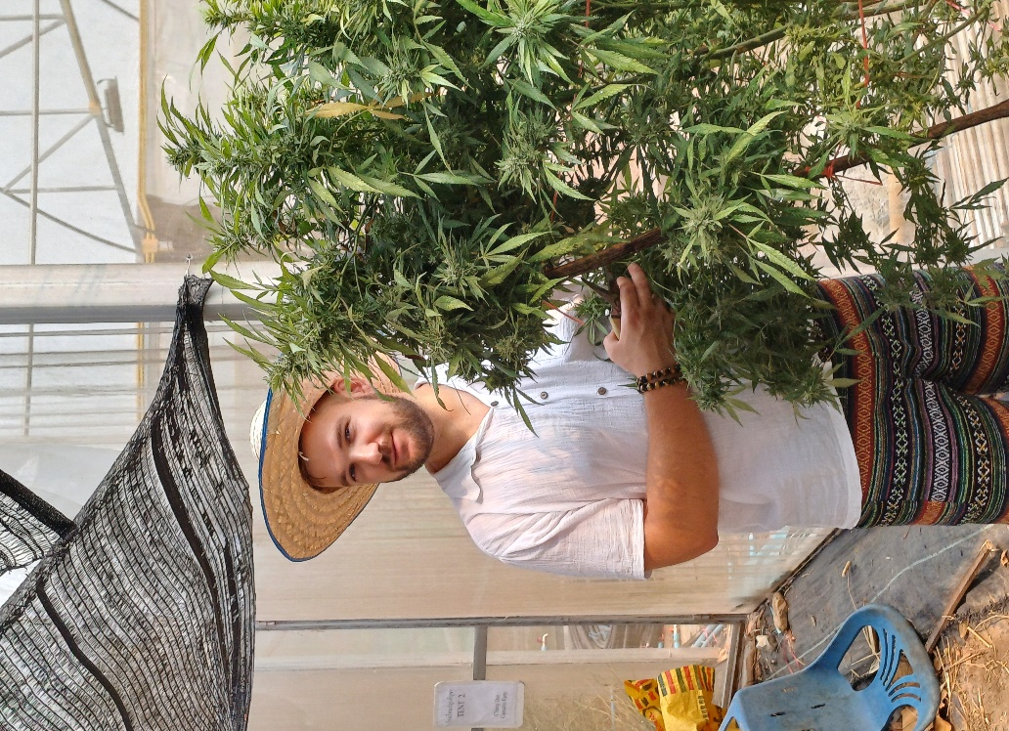 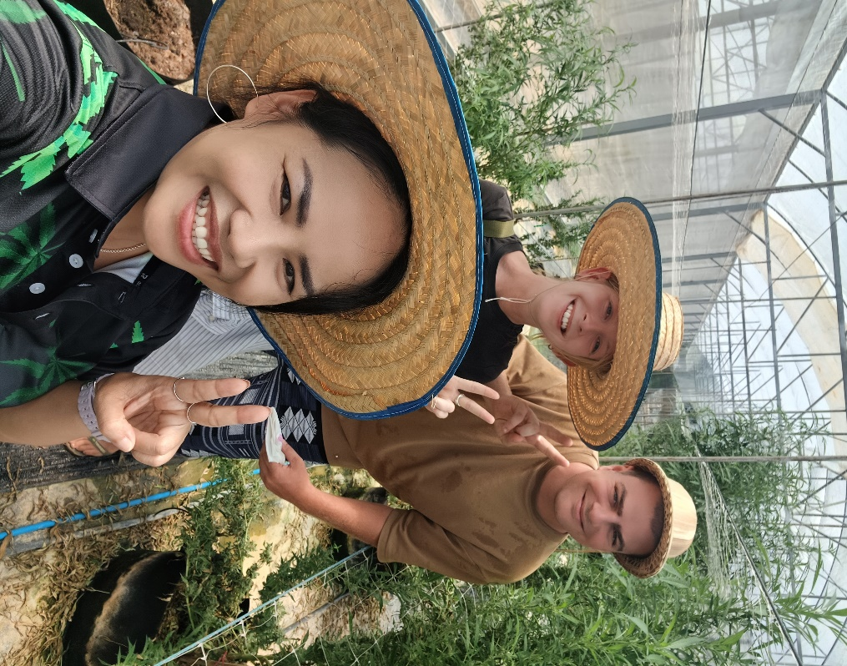

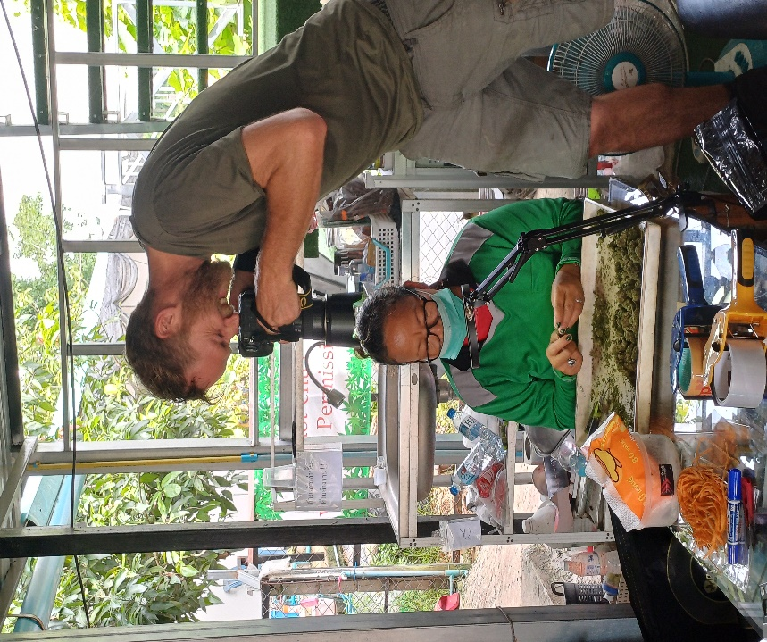 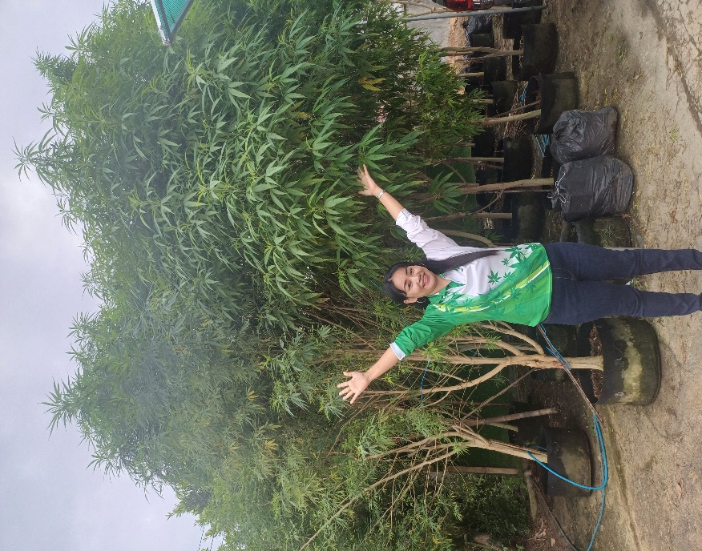

Program2

One Day

Cannabis Farm +Choose another program